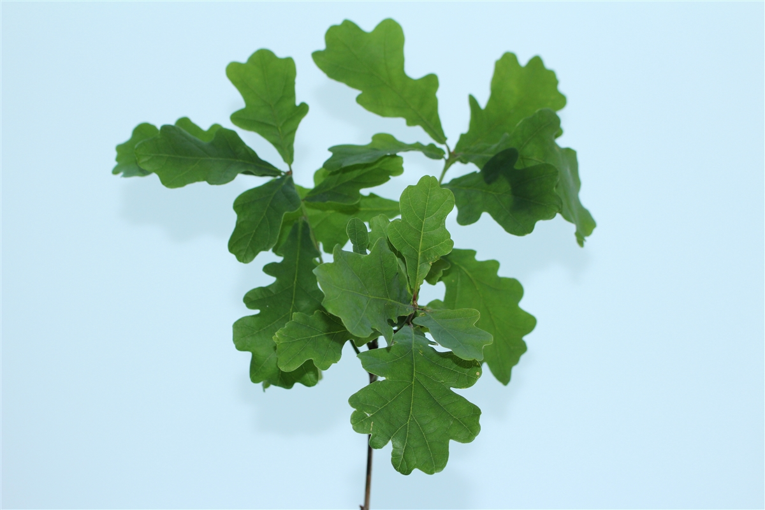
Annual Report

1/3/2021

Greener Every Day SCIO - SC050040

ANNUAL CHARITY REPORT AND FINANCIAL ACCOUNTS
YEAR 2019-2020

GED - Scottish Incorporated Charity Organization

Contents:

- The Management Committee
- The Charities Purposes
- The Beneficiaries
- Efforts put in to achieve our purposes
- What was achieved
- The impact

- THE MANAGEMENT COMMITTEE

TRUSTEES
CEZARY FLAK - CHAIR AND SECRETARY
LUKE WHITTLE - VICE CHAIR
MONIQUE SPEKSNYDER - TRESURER

2. THE CHARITIES PURPOSES

G
reener Every Day is an environmental charity, founded by a group of likeminded people that have a drive to make a change in the current climate crisis. Our core aims are to plant native trees within the UK, create awareness of the current crisis and how we can make a personal impact to overcome it, to create habitats and ecosystems that will sustain life for future generations.
A list of our purposes can be found listed below.
The organization’s purposes are:
The advancement of environmental protection and improvement by:
-1.1 planting native species of trees, restoring existing woodland and educating new generations.
-1.2 growing conifer and broad leaf forests in National Parks and where land has been donated or planting permission granted.
-1.3 reducing the effects of air and noise pollution.
-1.4 decreasing deforestation.
-1.5 relieving the spread of woodland disease.
-1.6 reliving global warming.
-1.7 reducing flooding.
-1.8 improving the levels of biodiversity.
-1.9 advancing the protection of endangered and threatened species.
-1.10 offsetting CO2 emissions.
-1.11 informing the public of current ecological problems.
The advancement of education by.
-2.1 educational talks in schools.
The provision of recreational activities by:
-3.1 securing and enhancing the enjoyment by the public of the natural environment.
And "The advancement of education”, “The provision of recreational facilities, or the organization of recreational activities, with the object of improving the conditions of life for the persons for whom the facilities or activities are primarily intended”

3. THE BENEFICIARIES

The charity helps communities in the areas we work in, by educating future generations and local people. We focus on content about the effect of climate change on our planet and the processes needed to combat it.
We organize different events in the area in an aim to encourage people to come together, socialize and build a community with a passion to make a change.
Greener Every Day helps to create better quality ecosystems and habitats where we carry out our work. We do this by planting trees which work with the surroundings to serve many different purposes. Not only are they providing a safe place wildlife thrive and grow, but they also have numerous important functions which make sure the people and wildlife are safe. They act as filters to reduce air pollution which help improve air quality. As barriers to reduce noise pollution. As natural flood defenses to help reduce the effects of flooding. But they also act as lungs for the planet, absorbing carbon dioxide from our atmosphere therefore reducing the speed of climate change.

- Efforts put in to achieve our purposes

The Greener Every Day team has been working on a voluntary basis over the course of this year. Running regular meetings and carrying out assigned tasks, working alone or as a team to contribute to the overall success of the charity in this annum. Each trustee has put in a large contribution of their time to carry out multiple projects some of which were more complex. As a young group of trustees, we have managed our workload well and learned many valuable lessons which have made us a stronger team and charity.
- What was achieved

This year has been a great success in our eyes, and we hope in the eyes of the general public to. We have achieved our goals and expanded more than expected, with new projects and some unexpected opportunities. Networking with amazing people, great companies and uncovering opportunities which could have easily passed us by, taking them on with initiative and passion. Completing projects which have been beneficial to our mission and has our team more rounded. Below is a list of our most treasured achievements this annum.
1. After months of hard work we have achieved registered charity status in Scotland. This has been a challenge which we have tackled with enthusiasm. Having done this we have also managed to get the essential context and material (such as expert opinion for our need) for registration in England and Wales which we hope to achieve in the coming year. This will give us the opportunity to expand in the future and effect more areas with our work.
2. In September we took part Solfest which is a Cumbrian festival based on the west coast of Cumbria. Here with a group of volunteers we worked on a small stall over the weekend, spreading the word of what we do, networking and providing a tree adoption service to the people there.
The tree adoption service was a way to interact with the public and help people make an impact on a personal level as well as interact with nature. We wanted to do something different and interactive. On this basis we created the Oak Tree Adoption Service. Here a member of the public can adopt their own oak tree, being able to interact with it by planting it themselves, naming it, making a badge as well as receiving a certificate of adoption with stated the effect the tree will have over its lifetime. Once the trees are planted in an accessible area the adoptee would also receive the location in the form of coordinates, which they could find and visit. (Due to Covid-19 these adopted trees have not been planted yet and as soon as they have, we will contact the adoptees to update them on this project and its location.)
During Solfest we planted and adopted over 40 Oak Trees. We also gained a lot of publicity and made many new contacts and followers during this weekend; we learned many valuable lessons for future fundraisers like this one.
3. This annum we worked with Workington Transport who is a vintage bus company in Workington. We worked with them to help them reduce their carbon footprint of 40 tons of Co2. When doing this we wanted to get out math’s right. We worked with an environmental expert to come up with our own equation which helped us understand the mean of Co2 absorbed by one of our trees on a yearly basis. Using this equation, we planted 250 English Oak trees near Penrith to offset the 40 tons of Co2 produced this year. This project was great fun, working with Sustainable Carlisle it took us one day to get them planted and protected from animals.
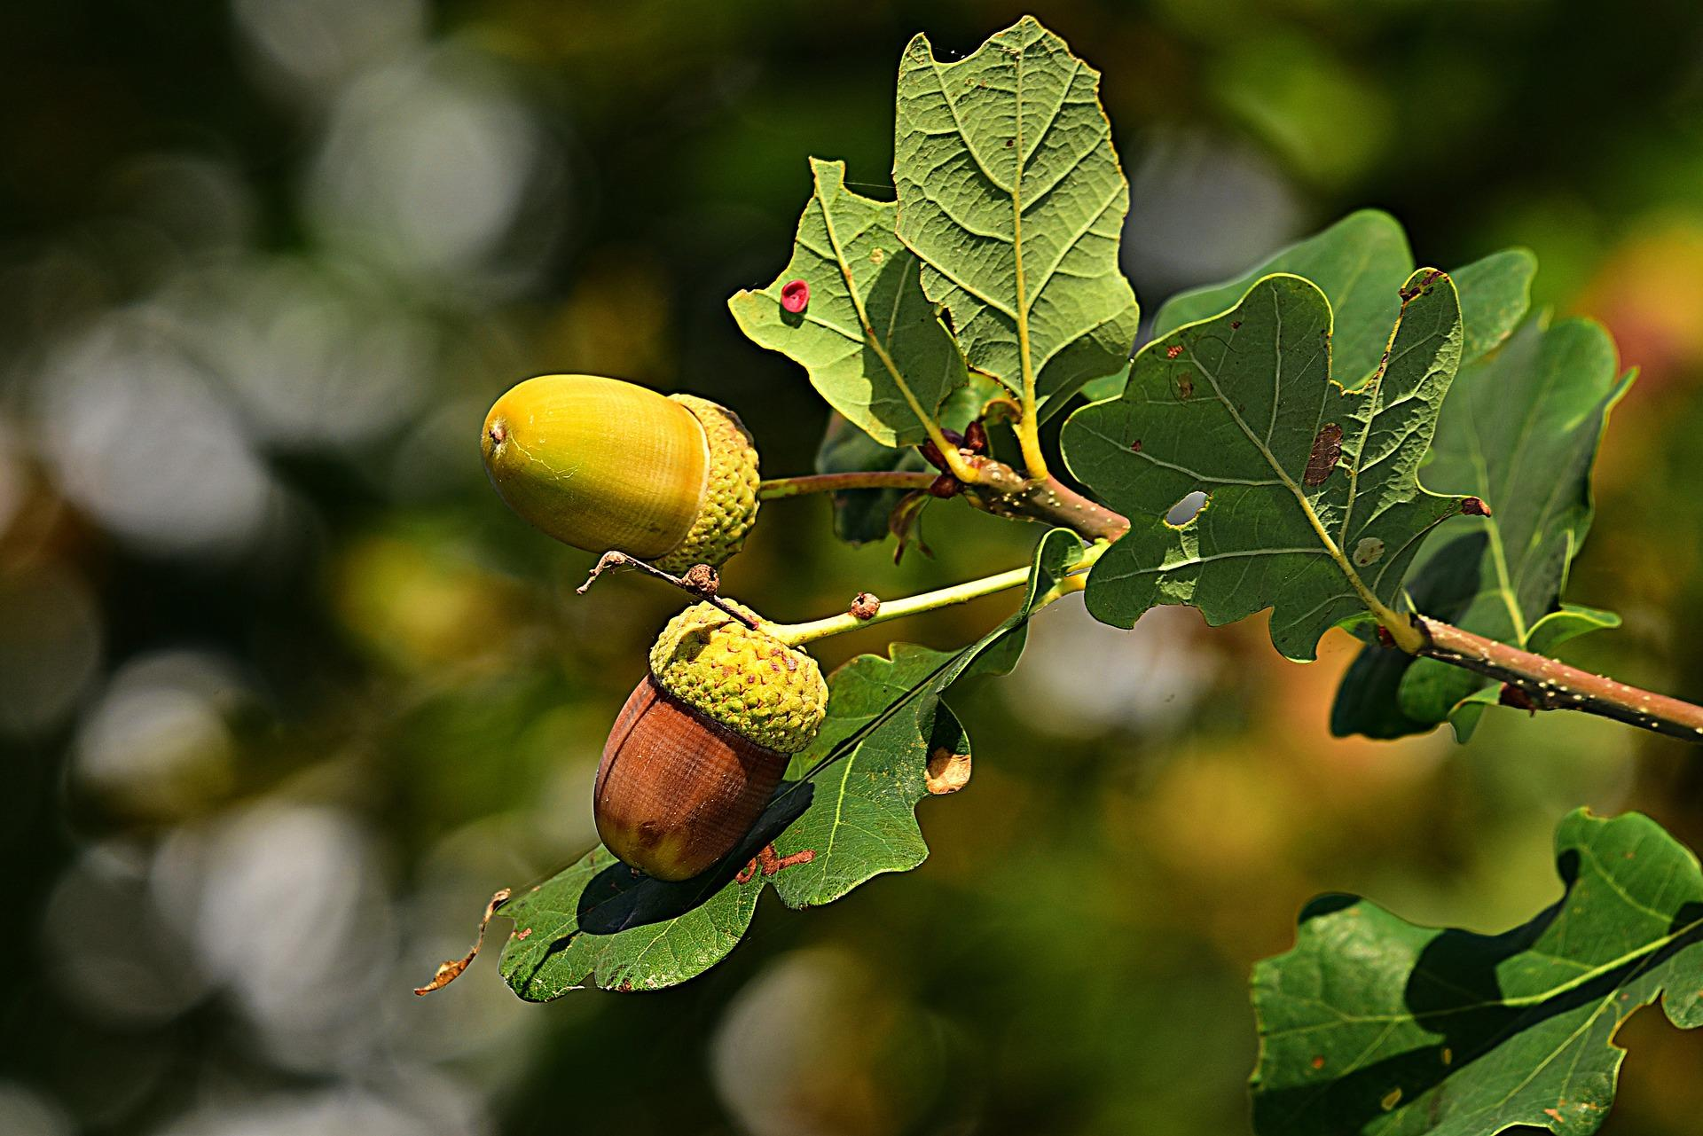
4. From June to September we introduced local schools to an acorn picking competition we organized. During this school pupils competed with other schools to collect the most acorns which we then planted in our nursery. Due to COVID-19 we have not been able to carry our educational talks and announce the winners/ give our trophies. We plan to do this as soon as it is safe to do so. Although, the competition was a great success and many children engaged and interacted with nature, sparking inspiration for this area of learning in schools.

6. Working with the Common Tread Group has been an incredible experience. Being introduced to this inspiring company which protects and improves the lives of children and young people in care we have built a strong relationship and carried out an amazing project.
During this project we worked closely as a team to ensure the best results possible. We distributed Oak Tree Grow Kits to 42 care homes across Scotland, from Inverness to Dumfries. Doubling our donations thanks to the quality of the goods. The kits consisted of organic and recyclable items which were also appalling, fun, modern and interactive. Something that grabbed an interest and was fun to work with. Coming with a simple instructing guide as well as a handwritten poem by one of our volunteers from Dumfries.
This project which everyone on the team is immensely proud of grabbed the attention of the media and we were featured on ITV Border news in July spreading the word of what we do to the general public. We are due to further work with the company to carry out educational talks after Covid-19 and carry out a follow up story for ITV.
8. For the first time this year and with the help of a charity friend we have started to establish our own nursery and learned about planting our own trees which was successfully. Although we have decided not to carry this out on a larger scale for the time being due to the intensity of labor and time involved. For now, and until we are more established to sustain this kind of ongoing project.
9. We have started to publicize our Co2 of-setting service which allows companies to work with us to offset their Co2 footprint, to begin on the journey to becoming carbon neutral. This is something we are passionate about and will be putting more energy into the coming year due to its positive effect on our fight against current climate crisis.

- The Impact

What difference was made - Impact
Looking at the impact made though our work and actions and the projects we have organized we have managed to make a difference. From having and positive impact on the environment to encourage young people to engage with nature. Fulfilling many of our purposes and objectives in the first year of being registered. We have a long way to go and big aspirations for the future. Bellow we go into more depth on the impact our work has had this year.
Successfully planting over 260 English Oak trees this annum has help to improve the environment, establish future eco communities sustaining thousands of species and carry our purposes fulfilling our objectives. In the future the trees will absorb millions of gallons of water from the countryside, absorb tens of tons of carbon dioxide from the atmosphere and make the local area an even more pleasant place to live in. Improving the quality of life for the people and the inhabitants of the forest.
Running the school acorn picking competition and distributing the interactive tree growing kits. We have introduced, engaged, and connected hundreds of young people with nature. Growing your own trees and watching what it goes through to get to maturity. Sparking an interest in the natural world and an awareness around the environment and our climate. Following with the educational talks this will be a life changing spark in interest for many of these young people. This is so important for the future of our planet as these young people will play a crucial role in the years to come and will hopefully do their bit in the future, to tackle and to pass on knowledge of the current crisis.
We have raised awareness and inspired hundreds of people around the areas we work in to help to care for the environment.
We have gained essential knowledge and skills around running a nursery and growing our own trees, these are useful skill for the future when we plan to grow our own trees from seed in a sustainable way.
We have made may connections with communities as well as companies. This will help us carry our work in the future as well as generate new opportunities for growth and success, improving the impact Greener Every Day has.
We are now a registered charity in Scotland and are acting as an unregistered CIO in England with our constitution in place, awaiting registered status in both areas of the UK in the future. This is a great achievement which helps us expand our horizons and lets us carry our work more efficiently and on a bigger scale. It opens many doors which will help us make the biggest impact possible.
We have engaged with multiple volunteers who are members of the public and have started to establish a network of people who can come together to help the charity. Bringing together the community and creating a network of relationships for local people.

Financial accounts
Below is a set out of Greener Every Days financial accounts for year 2019-2020.
These accounts show how we have successfully managed our finances this financial year to carry out our projects. Achieve our goals. Fur-fill many of our purposes and be financially solvent in the end of the year. This is the first year of our existence and we hope to improve our finances in the coming financial year further, having come a long way and this year.
NAME | DEBIT | CREDIT
Admin Costs | £112.00
Cumbria County Council Grant |  | £638.00
Fundraising in Kirkcudbright |  | £90.63
Meeting Costs | £111.00
Project Common Thread |  | £697.91
Project Penrith Schools | £20.00
Project Solfest | £465.88
Trees and Planting Costs | £904.52
Workington Transport Trust |  | £400.00
Donations |  | £128.37
Total | £1614.00 | £1954.91
Current Balance | £340.91

